**TERRAFORM TASK 6**

Execute the script shown in video.

main.tf

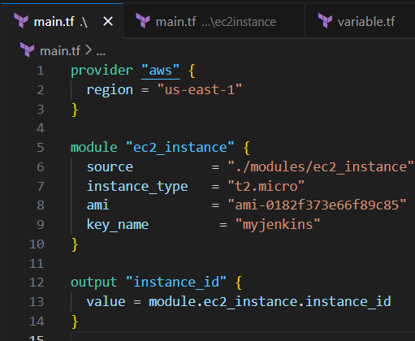

**main.tf \ec2 instance**

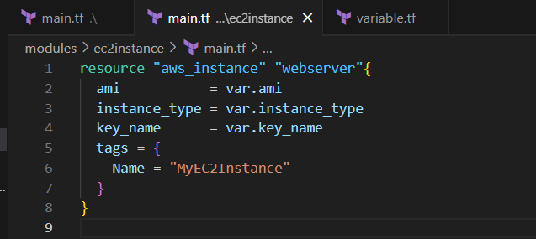

**Variable.tf**

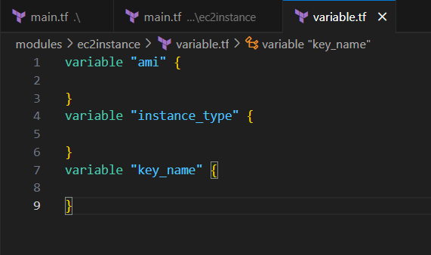

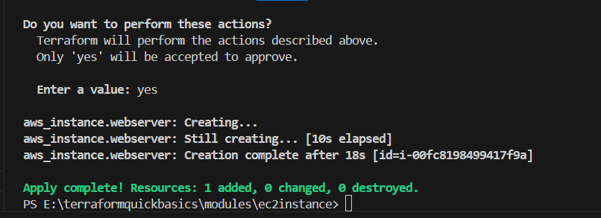

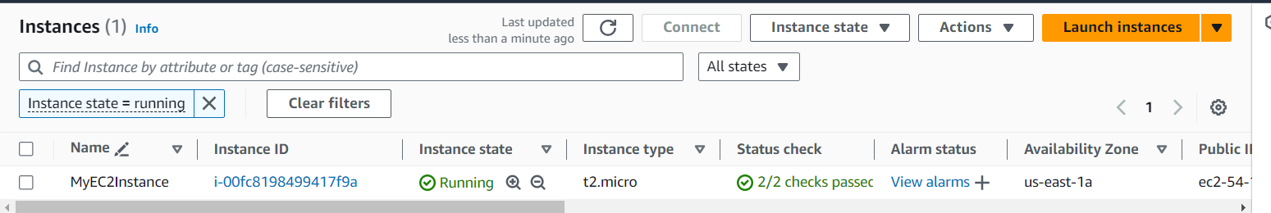

**Terraform workspaces**

**To create a workspace in a new terminal of vs code we need to give**

**Terraform workspace new project name**

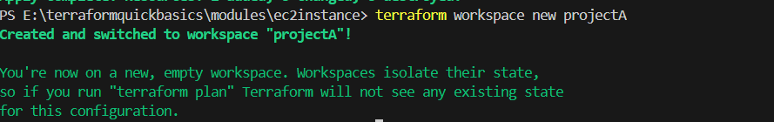

**To list the workspaces available we need to**

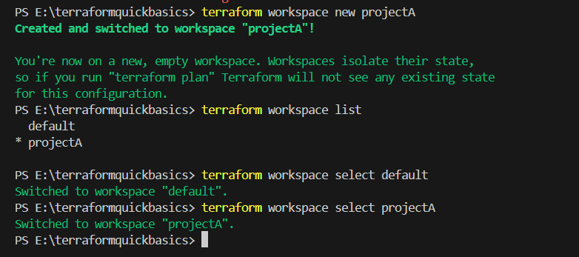

**Created s3**

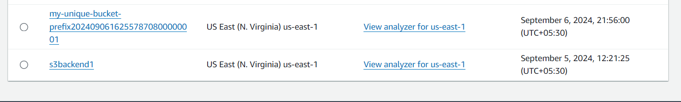

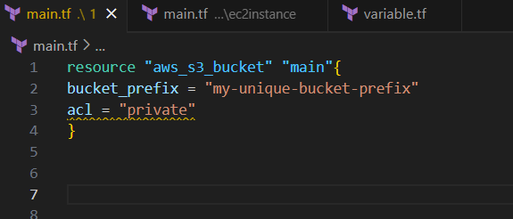

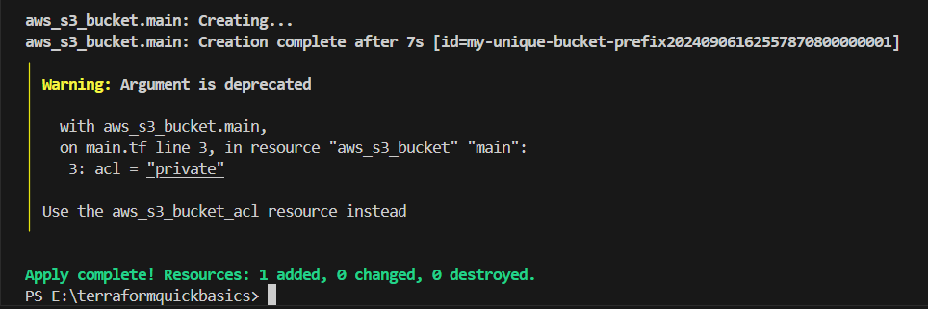

**VPC-main.tf**

**Resource “aws_vpc” “main”{**

**Cidr_block = “172.68.0.0/16”**

**Enable_dns_support = true**

**Enable_dns_hostnames = true**

**Tags = {**

**Name = “main-vpc”**

**}**

**}**

**Output “VPC-name” {**

**Value = aws-vpc.main.id**

**}**

**Root-main.tf(declare modules her)**

**Provider “aws” {**

**Region = “us-east-1”**

**}**

**Module “VPC” {**

**Source = “./vpc”**

**}**

**Module “s3”{**

**Source = “./s3”**

**}**

**Variable.tf**

**Variables “region”{**

**Description = “region to deploy resources”**

**Default = “us-east-1”**



**Main.tf/root:-**

**Provider “aws” {**

**Region = “us-east-1”**

**}**

**Module “ec2” {**

**Source = “./ec2”**

**Environment = var.environment**

**Ami_id = var.ami**

**}**

**Output “instance_id” {**

**Value = module.ec2.instance_id**

**Ec2/main.tf:-**

**resource “aws_instance” “main” {**

**ami_id = var.ami_id**

**instance_type = “t2.micro”**

**subnet_id = “id from vpc”**

**tags = {**

**Name = “${var.environment}-ec2-instance”**

**}**

**Variables.tf**

**Variable “environment” {**

**Description = “defining the environment prod,dev,staging”**

**Type = string**

**}**

**Variable “ami”{**

**Description = “giving ami name”**

**}**